**Lab – 7 Datasheet**

**CpE 4010: Sensors, Actuators and Integration**

|  |  |
| --- | --- |
| Name: Anindita Deb | KSU ID: 000922115 |

**From procedure 3:**

**Insert your picture of your LCD screen displaying texts from the sample code here:**

**From procedure 5:**

**Insert your picture of your modified circuit, showing the LCD screen, and screen shots of your modified code here:**

**From procedure 6:**

**Insert your picture of your modified circuit here:**

**From procedure 9:**

**Insert your pictures of your modified circuit, showing different water levels measured by the water level detector here:**

**low**

**Medium**

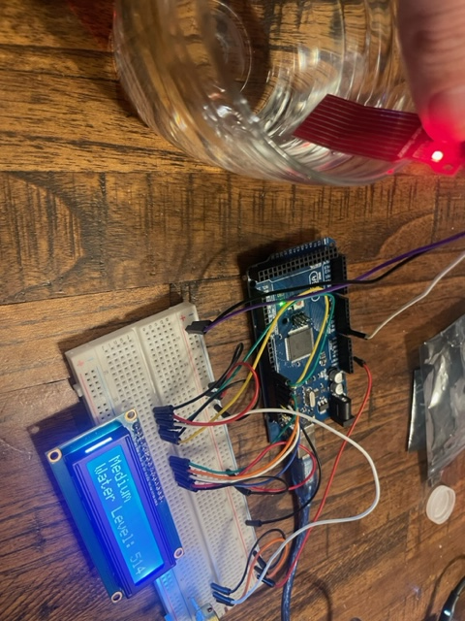

**Full**

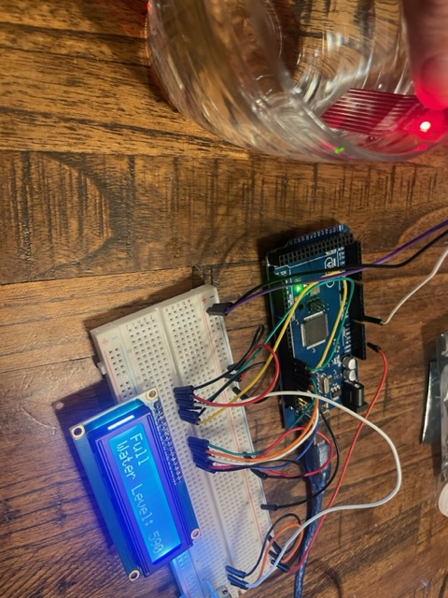

**From procedure 10:**

**Insert your picture of your modified code here:**

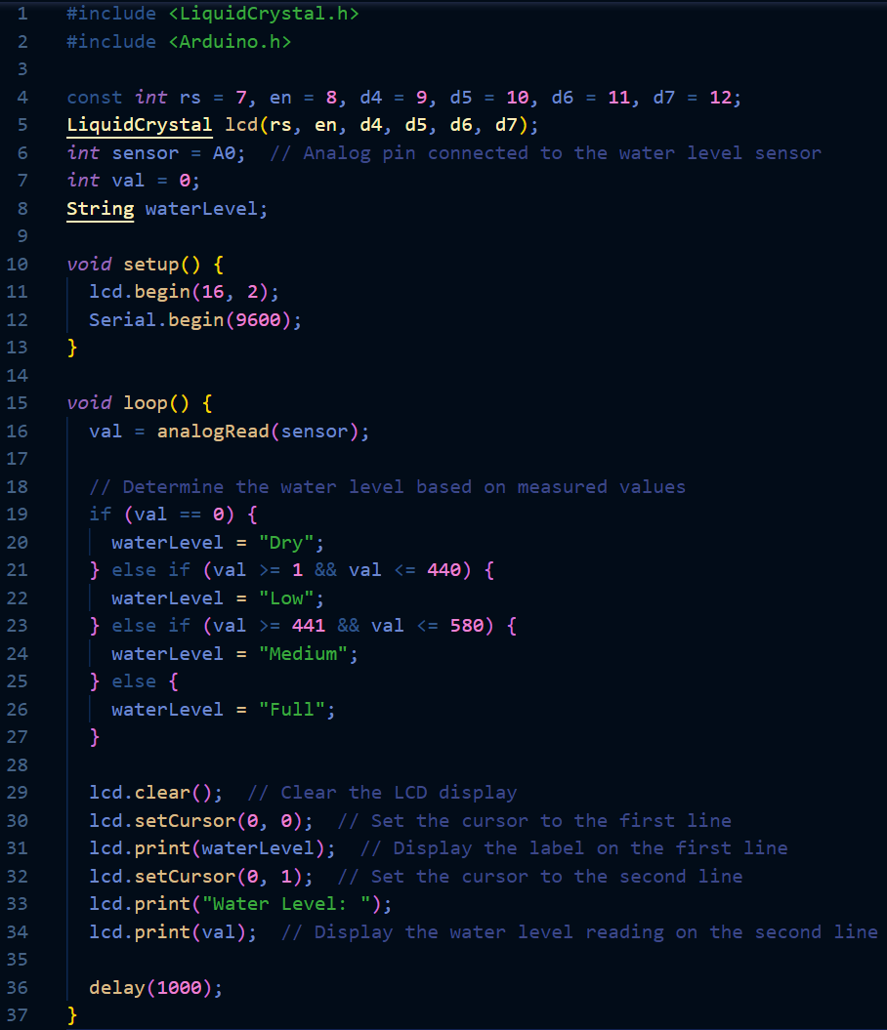

**Conclusions:**

troubleshooting was required for the water level sensor, as immersing the sensor in a cup of water caused the readings to spike into the upper 300s and lower 400s. Consequently, a more reasonable low value was established, while the medium and full readings were adjusted to be more normalized. There were no other issues encountered during circuit assembly or the setup of the water sensor. Overall, the lab was enjoyable; however, the sensor's unpredictable readings were somewhat disappointing.